Joel Lantigua

Linux administrator

File sharing with two servers

9/12/22

File sharing

To File share between my Ubuntu server and my CentOS server I first I need to check if my SSH is active and running on both servers by using the command **systemctl status sshd** for CentOS and **systemctl status ssh** for Ubuntu in my case its active and running as you can see below, If the SSH is not active replace **status** in the commandfor **enable**. Text

Now that the SSH is active and running we are going to get a record of each servers IP address so that we can use it to connect to the server remotely. The command we need to use so that we can see the servers IP address is **ifconfig.** note this command works for both servers. As you can see in the image below that my CentOS IPaddress is 192.168.241.142 and the IP address for my ubuntu server is 192.168.241.136.

Next download Putty on <https://www.putty.org/>. Once putty is installed and open type in one of your servers IP address where it says **Hostname (or IP address)** then click open. After you click open you should be connected to the server and the server is going to ask for the users login. Use the same login that you created when setting up the server. Repeat the same step to connect the other server remotely on putty.

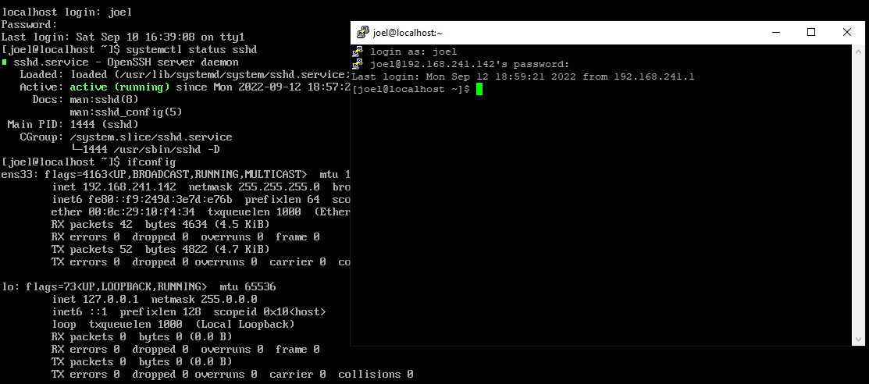

Now that we have both servers connected remotely using putty, we are going to create a directory on the ubuntu server so that we can put a text file in it to share with the CentOS server. First, we are going to be using the command **mkdir (followed by a directory name)** to create a directory. I used the name “**share”** for my directory on the Ubuntu server, so the command would be **mkdir share,** you can use the **ls** command to see if the directory was created. Then I used the command **cd share** to change into my “share” directory. Once you are in the directory that you created, we are going to use the command **nano (followed by a file name)** to create a text file**.** I named my file sharePlease so the command would be **nano sharePlease**. In the nano window type in whatever you want, then hit **CTRL x** and save the file. After the file is saved, we are going to give the text file you created using nano executables rights by using **chmod +x (the name of the file).** To confirm that the file was given executables rights use the **ls** command and the file show be a neon green color as you can see below in the screenshots.

Now we are going to send the text file we created on the Ubuntu server to the CentOS server we have remotely connected. By using the **scp** command, but first I created a directory called received on the CentOS server. After the directory is created switch back to the putty window where you created the text file using **nano**. Once you are back at the server window with the text file you want to send use the command **scp -r (path of the text file) (followed by the name of the of the server) (destination server + IP address): (location of where the file gets placed).** In my case the command would be **scp -r share/sharePlease joel@joel joel@192.168.241.142:/home/joel/received** Once you hit enter the server you are sending the file to will request the password for it. After the password is inserted, you should see the file name followed by 100% indicating that the file was successfully sent.

Now you can switch to the putty window of the server receiving the file, for me it would be CentOS. After switching to my CentOS server, I changed into my “received” directory. Once I was in the received directory, I used the **ls** command to see if the text file was there. As you can see in the screenshot below. You can use the **cat** command to read the text file. So, the command would be **cat sharePlease.**

